
JUST.EQUIPPING

Report - Africa – Great Lakes Region & Cameroon

January 29 – April 15, 2008

I find it very difficult to distil into a report all that I have to say about our Africa Great Lakes Region & Cameroon – 2008 adventure. I do not know how to share the great blessings and overwhelming hardships, the love and distrust, the corruption and the dedication. I only know that our days were crammed with teaching, sharing, listening, learning and looking with wide eyes at all that passed by.
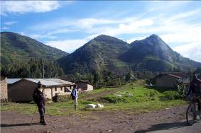

RWANDA

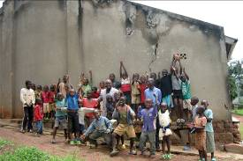
The first team consisted of Eileen Henderson (MCC Toronto), Philippe Landenne, sj (chaplain, Belgium), Jeff Denault (video-photographer and cook, Ottawa), Emanuel and Marylène Krebs Têtu (photographer, journalist, Vancouver), and Pierre and myself. We set up headquarters at the Iris Guest House in downtown Kigali and immediately began to welcome old and new friends in for Fanta, cheese and bread. Traffic was constant, discussions were fascinating and we nailed down the schedule for the next 10 weeks. Our first Sunday was spent in the little Gatsata church and the Kigali Central Prison. We had convinced Philippe to put a tie on for the first time in 20 or more years. About fifteen minutes later, as we were waiting for our ride out to start the day, there was an earthquake (5.4) and a huge crack streaked across the front wall of the clay-brick church. No one in our area was hurt, but Philippe could not help but remind us that he had known that no good would come from making him dress up.

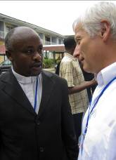
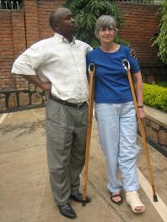
Our official teaching sessions in the Great Lakes Region were organized in partnership with F.E.P. (Fraternité évangélique des prisons) under the able leadership of Reverend John Ngabo and his committee from Rwanda, Burundi and RDCongo (Kivu). The first full Rwanda week was Restorative Justice Basic Training with 21 chaplains, both clergy and volunteers. It was held at the Anglican Guest House in Kigali, and Pierre, Philippe and Eileen gave sessions on RJ Values and Principles, Wall of History, Models of Chaplaincy, Biblical Justice and RJ, RJ and the Offender, RJ and the Victim, Steps to Healing, RJ and the Community, Working with Women, and Mission and Vision. Participants shared, did role plays, built their Wall of History, prayed, reflected, sang and danced. I tried to create a series of tangible materials for daily prayer and reflection to custom fit the group, so we built a colourful paper house with bricks, each representing the values and techniques learned. (These prayer and reflection props varied with each week and cultural setting.) Eileen was a bit late that week as she had walked into a drainage ditch and broken her leg! She finally made it to class after surgery and several harrowing days in hospital. Jeff talked about mountain climbing and demonstrated his equipment. There were huge eyes (and many giggles at the crazy Canadians) as he donned his rock climbing gear in front of the class. Emanuel explained some fascinating photo facts and his work and hobby of snowboarding. Each new piece of information helped to illustrate the necessity of keeping our minds open, ready to see the world in a different way, willing to try new ways to react to injustice and practice justice.

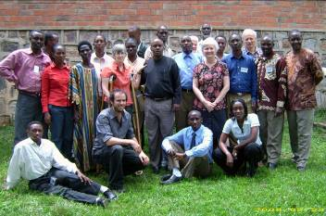
The next full week was Restorative Justice and Pastoral Care with 17 students, a follow-up to the basic week. After a brief overview of RJ and practical pastoral theology, Pierre, Philippe and Eileen looked at the ministries of Presence, Listening, Preaching, and our Prophetic ministry. The students were sent out each day to conduct structured interviews. They then shared verbatim reports the following day, and their strengths and weaknesses were analyzed. We had a good time in this course, enjoyed each other, laughed at the odd and interesting things we try to do in the name of ministry (ie arriving at someone’s home at 7:00am, chatting about inappropriate inanities), and hopefully became more skillful in our ministries. Again, the week ended with a cake and certificates!

We were involved in several very important community initiatives in Rwanda. We spent time at the University of Butare Legal Aid Clinic under the invitation of Appolinaire Kayitavu Mpumuro. We listened to cases being heard by law students involving genocide after-effects such as land disputes (les parcelles!), body recovery, revenge crimes and health issues. They shared their program with us and their needs and we encouraged them to look for means to give basic training in law and human rights to chaplains so that they can be more effective in their prophetic role.
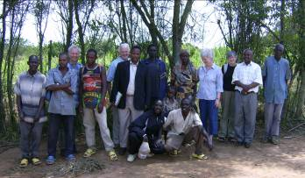
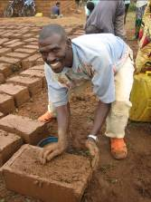
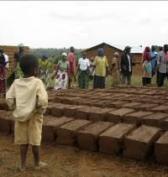
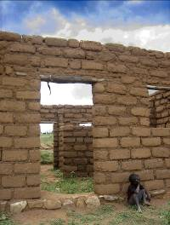
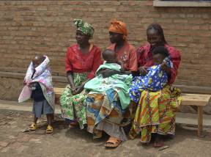
We traveled several times to Bugesera province where there was a widespread massacre of Tutsi over several years. As a result of initiatives taken by F.E.P. and John Ngabo, community collectives are growing. In these, widows and genocide victims work side by side with perpetrators and ex-offenders to rebuild houses, develop sustainable agrobusinesses (honey, cassava, pineapple) and provide school fees for children of both victims and perpetrators. We have rarely seen such an inspiring and moving project as Twungubumwe (Let us make unity) under the leadership of Pascal Niyomugabo, himself a survivor. We are anxious to do a DVD on this moving and important initiative and to look at possible creative applications here in Canada. We were able to offer a one-day seminar and dinner to 30 Twungubumwe collective leaders. The participants were amazingly forthcoming in their sharing, reliving raw, genocidal experiences and their attempts to find justice and reconciliation. Dinner – rice, potatoes, chicken, isombe, stewed beef, cabbage salad, and fried plantain – all cooked outside over a fire, was great too, and very moving, as actual survivors and perpetrators sat beside each other on the grass and shared a meal. We presented this group with clothing, baby blankets handmade by dear friends here in Canada, and some tarpaulin sheeting to protect the clay bricks they make for housing. If rain comes before the bricks are dry, they are ruined!

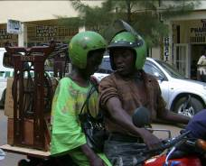
We spent time with the Mamans Naomi, a women and children neighbourhood group initiative with Sophie and Louise. Eileen and I went downtown with Sophie to buy a sewing machine. We got one at a good price, thanks to Sophie who bargains like the true pro that she is. We then watched in horror and fascination as she was loaded onto the back of a taxi motorbike with the machine and rode off into the pot-holed sunset. Several donors from Canada had given money for sewing machines and a knitting machine for this group as they work towards sustainability. They were very grateful, and appreciative of any contributions of thread, wool, material, sewing lessons, etc. Both Eileen and later Susannah Shantz spent time with them. One Saturday afternoon there was a super neighbourhood party with Jeff taking over 200 pictures of the kids and parents, Philippe drawing cartoons, and lots of singing, dancing and praying. Wonderful!

We also got to know INEZA, another sewing workshop for women who contracted AIDS due to genocidal rape. They receive AIDS medicines through a UN initiative, but they were taking their pills on an empty stomach and getting sicker. They simply could not find food to eat every day. Frank, their organizer, was instrumental in helping to organize a cooperative mini-business with them so that they would have sufficient food to be able to absorb the medicines. He tries to market their impressive product but it is an uphill battle. They are a fantastic bunch! Our help was small, but we tried to encourage and promote their business, and offered cookies and some money for seeds to plant vegetables.

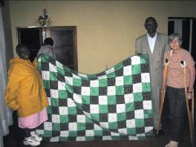
We visited and spoke in various prisons and were able to return to some more than once. Eileen presented a quilt made by the inmates at Grand Valley Institution to the women in the 1930 Prison Centrale de Kigali.
The inmates are a varied and needy group, most waiting years before being officially charged. It is hard and expensive to get a lawyer, so most do not have one. Then, since the political power brokers often change, the line between victim and offender in jail is often blurred. Many of the genocide-related offenders were clergy or church related, and so the church inside is often strong and very well orchestrated. The physical conditions in the prisons are usually abysmal, with frequent overcrowding, fellows living and sleeping outdoors on makeshift soccer fields with no protection from the elements, on cement floors, or stacked side by side on narrow shelves. There is widespread hunger. Very often, those who can find a bit of money can buy food cooked up by fellow inmates in their corner of the prison. Those who cannot, often go hungry. In either case, what there is to eat would not sustain you or me. If you are going to be in prison in Africa, do not get sick. There is little or no health care capacity.

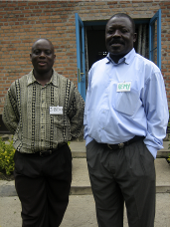
The plight of incarcerated women is particularly bleak. They are often housed on the floor in small, damp, windowless concrete blocks or in dormitories where they are stacked like sardines on narrow, airless shelf-like beds, 3 or 4 high and dozens in a row. They use any bit of old cloth or cardboard to create a bit of privacy for themselves. They have no hygienic products and would love blankets or sheets.
In Gysenyi, we brought bread, fruit, baby blankets, clothes and educational materials to the mothers and babies in Central Prison. In return, they sang and danced for us and we left feeling doubly blessed.

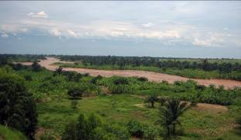
The month of March was a traveling month. Eileen returned home, leg cast and all. Emanuel and Marylène went back to real life in Vancouver. David (chaplain, Correctional Service Canada, Montreal) and Susannah Shantz arrived having lost nothing along the way except David’s briefcase with all his course notes, tickets and Bible. The fact that they had left a severe snowstorm to land in a balmy, beautifully soft tropical evening helped to mitigate the loss.

Burundi

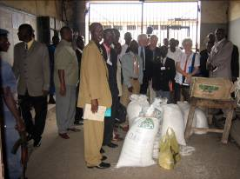
Pierre, Philippe and David offered the Restorative Justice Basic Training to 18 students in Bujumbura, Burundi. They expressed pain over constant battles with violence, corruption, poverty and hunger. And yet, simultaneously, they told stories of faith and miracles that strengthened everyone. One chaplain told of being kidnapped by rebels and forced to dig his own grave. At the last minute, they allowed him to go for a ransom – his house and property. He and his family were left penniless and refugees. Once again, the idea that RJ involved respect towards community, offender and victim, and requires work toward listening, truth-telling and restitution seemed to fill an enormous need in moving forward in their difficult lives. On Friday afternoon, we were proud to present them with certificates from Queen’s Theological College, our partner in RJ teaching. Again, after the course, a luncheon and day seminar was organized for government and prison authorities. It is always a privilege and a challenge to meet these people and present to them while being very aware that we are not living in their shoes or carrying their responsibilities.

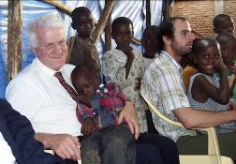
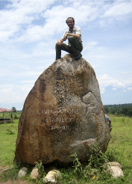
We visited the Prison Centrale Mpimba with 465Kg of rice and sugar and 700 bars of soap, and had a wonderful service together with 400 people from the ‘church inside’. Of course, all those being held in the prison were not at chapel. We tried to connect with them, however briefly, through the barred windows and interior rooms where they were warehoused, but the guards hurried us on and out of sight. Many did not look well. The facilities were inadequate and oppressive. Poverty and need glared at us.
Our host, Jean Bosco Manihankuye, also arranged for us to worship with two local churches and spend time with local families. At one (long) worship service, a couple of darling little fellows fell asleep in Pierre’s lap. We survived heat, humidity and travel on roads with crater-sized holes, and Jeff got to have his picture taken on top of the Livingston-Stanley monument at Mugere: ‘Mr.Denault, I presume….’

RD Congo

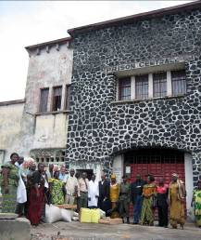
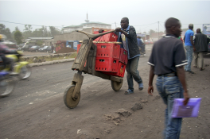
We then spent 10 days on the RD Congo border in Goma and Gisenyi where we were joined by Jean Didier Mboyo, IPCA Africa. Seeing the city of Goma for the first time was shattering. In 2003, two thirds of the city was covered with up to 4 metres of lava after the eruption of Mount Nyiragongo. It is impossible to describe how the inhabitants have managed to carve out shelters for themselves and their families on top of this dusty grey-black rock. How do you keep your children clean? Will you find enough wood today to start a fire? How do you find money for food? Where do you seek medical help for malaria, fever and dysentery? What do you do about school fees due several times a year? Will there be violence or a rebel incursion today? Who has time or energy to think about prisoners? Nevertheless, a stalwart group of chaplaincy volunteers accompanied us to the Prison Central de Munzenze where we were allowed to visit all the sections, adult, female and juvenile, to chat, and to see first-hand the needs and realities of that filthy, tattered corner of God’s kingdom. Everywhere, the prisoners call out: Look at me Mama, help me Mama, I am hungry, Mama, I am sick, I am your child….Once again, we brought basic food staples, soap, and medicines. We accompanied the nurse-chaplain-volunteer to a small, dirty corner consecrated to health care where he reverently took the bag of meager medical supplies and thanked us with emotion. I had the feeling that I was on holy ground which I could not properly appreciate. When we prayed with these sinners and saints, we needed words from the Spirit – we had none of our own that would do.
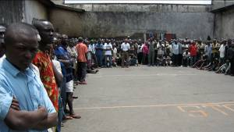
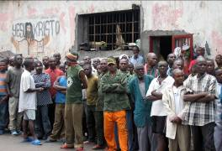
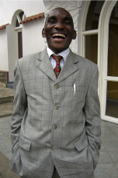
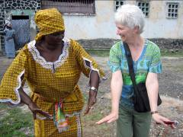
The RDCongo Restorative Justice Basic Training was held at the Presbyterian Guest House in Gisenyi, across the border in Rwanda. Sixteen chaplains had their first taste of the principles of non-violent justice practices. They shared deeply from their own painful experiences. All were victims, some offenders, and yet they were committed to prison and justice work, largely in thankless conditions. When the Wall of History was constructed, with its three parts – personal, political and prison, the participants prayed and lamented over it at length, stirring up images of the Wailing Wall in Jerusalem. On the final day of courses, the students presented a play in which RJ principles were looked at in light of the theft of a goat by a woman who wanted to prepare an impressive dinner for her mother-in-law. When brought before a magistrate by her wronged neighbour, her defense was that it could not possibly be her neighbour’s goat because: Everyone knows her goat’s feet turned inward, whereas the one I killed and cooked for supper had legs that splayed outward! Laughter IS good medicine.

In Goma, we were privileged to be able to offer a one-day seminar on RJ to the North Kivu government officials. Philippe gave an overview of RJ and RJ principles. Pierre addressed correctional values and best practices. David spoke to the role of chaplains in justice and prison realities. Repeatedly, we were confronted with issues and questions around poverty and corruption. How do judges who receive a salary of less than a dollar a day provide for their families? How do communities deeply fragmented by tribal and rebel factions work together for their own mutual benefit? Why should efforts be made to supply medicines and food to prisoners when staff and outsiders – including victims – are suffering? Who will pay transportation for chaplains to travel to prisons for services? How can they offer spiritual care when the men and women to whom they minister are barely holding on to life? How can anything get organized when money for telephone cards is so hard to find? How were the authorities going to get home from our one-day training? Who had bus fare? Taxi fare? Would we please come back?

Cameroon

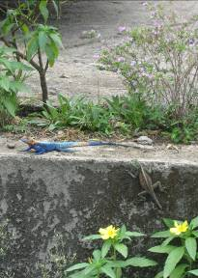
In April, Philippe, Jeff, John Ngabo, Pierre and I flew across the continent to Douala, where we were met at the airport by Sister Jackie Atabong and Sister MaryBen. We were very thankful for their welcome, as getting through and out of the airport is a study in heat, crowding, confusion, bribery and dishonesty.
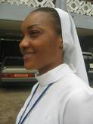
We had the privilege of visiting the Central Prison in Douala where Sister Jackie works. I use the word ‘privilege’, because it is absolutely necessary that places like the inside of this institution be shown to the community and the world at large. Violence, aggression and tension were throbbing in the air. The prison was overcrowded, and as we tried to make our way through, inmates beat other inmates with whips to keep them from coming close enough to try to talk to us, or ask us for help.

Guns had been found inside the prison and the offenders deemed responsible had been shackled to a wall by their ankles, their backs left dangling on a damp and dirty cement floor. They looked haggard and sick and yelled at us as we passed by to act upon this terrible infraction of human rights. Hundreds of bodies milled around with nothing meaningful to do. Sister Jackie took us to a cramped craft and sewing workshop she had managed to set up where she and her volunteers trained inmates to make school uniforms and carry-all bags. A ray of light and hope! The staff accompanying us were clearly overwhelmed by the enormity of the situation, and my heart understood how they could so easily become numbed to the despair. Only a divine calling could enable chaplains to return week after week to this place.
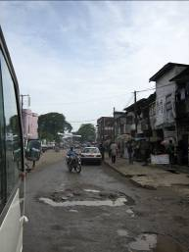
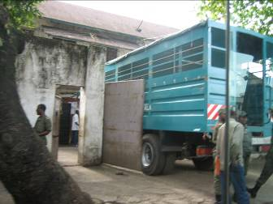
Sister Jackie had arranged for 50 participants to take the RJ Basic Training week in the town of Limbe on the coast. Most of the participants were from the ICCPPC (International Commission for Catholic Prison Pastoral Care). They came from Cameroon, Nigeria, Congo, South Africa, Ivory Coast, Ethiopia, Ghana and Tanzania. We added one new element to the course. John Ngabo presented the situation in Rwanda prison work and several DVDs were shown. For many, this was their first training in any aspect of prison work and they were anxious for material, books and sharing. Again, at the end of the course, it was a joy to present them with a Queen’s Certificate of Participation and to ask God to encourage and protect them.

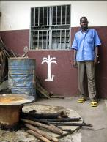
A visit to an aftercare facility and a prison nearby again brought us face to face with reality. The main issue to confront us in the prison was the lack of adequate health care. As Sister Jackie is a nurse, she sets up dispensaries wherever she can. We brought our small contribution, as usual, but it did nothing to ease the pain of seeing rampant skin infections, malaria, hunger, injured bare feet and even an untreated broken arm. We left pairs of rubber sandals with the chaplain and wondered how we could convey to our friends and family at home what it would mean if they all gave one or two pairs of summer flip-flops. This simple, easy gift on our part would ease the lives of innumerable people.

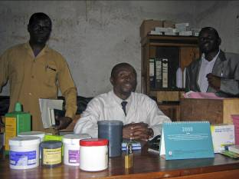
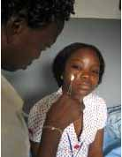
During our time in Cameroon, I made several trips to a local clinic with various participants and team members who were sick and who could not otherwise have afforded a visit to a doctor. Malaria, of course, is the ever present phantom. To determine if you have malaria, you take a blood test. Hopefully the clinic has a malaria kit available. Then, depending on the result and the type of malaria contracted, you receive an oral medication, or a heavy-duty series of injections or hospitalization. After paying the doctor, you take your prescription to a pharmacy, buy the medication and return to the clinic for treatment. This, of course, requires long walks in the heat while you run a fever, or finding money for a taxi of some sort. If a vial is accidentally dropped by the medical personnel (as happened to one of us), you start over. If, as on another occasion, surgical intervention is required, be prepared for many steps to the cure: trips to town to the pharmacy for sterile gauze, disinfectant, a bandage, a vial of pain medication for injection, an antibiotic. On another of my trips to the clinic, a baby had undergone emergency surgery during the night. He needed a blood transfusion, but there was no money and the parents who lived further up the hills were desperate. The doctor asked if I would buy blood for the baby. Again, there were the trips on unbelievable roads to get what was needed. In the end, the baby received the transfusion, but it was too late and he died shortly after. We sent a care package to the grieving parents, and wondered how to reconcile our lifestyle with the lifestyle of this lovely little family, or that of the doctor and nurses in this clinic. They were devastated as they realized their limitations, and yet, they carry on!

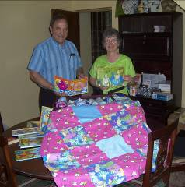
One of the great reliefs towards the end of our adventure was that the baggage we were hauling around was shrinking in size.
(Let me add as an aside here that Bethany Baptist Church in Ottawa is a twin with Gatsata Evangelical Episcopal Church and school in Kigali. Bethany had collected and filled 75 bags with school supplies, craft supplies, letters and many other items. Pierrette, from our office, had created a large number of sustainable school teaching aids. We agreed to bring these items with us). We provided pens, pencils, notebooks and binders for all participants in the RJ courses. We also gave a symbolic gift to each person at the end of each course to underline our solidarity with them in their work. This consisted of small gifts of money, tea, sugar, books on RJ and prison ministry, markers and, thanks to Michel from Montreal, Just.Equipping pens and mini-flashlights! One of my personal goals for ‘next time’ is to be able to provide pens and paper to the juveniles in prisons who are trying to do some schooling. School consists of an outdoor class led by another, usually older, inmate, often a former teacher. Materials are a board painted black and a few pieces of chalk. There are no books, notebooks, pencils, desks or other resources. You need to be quick to retain information – there are no second chances!
Eye glasses are in demand, whether they be used or non-prescription. Our chaplains gobble them up – there are never enough to go around. A bottle of Aspirin or Advil is a coveted commodity. There are never enough malaria pills to go around either. Every chaplain struggles to find the money to travel to and from prison visits. Many of their children are not in school because they cannot afford the school fees. Food is always an issue. School uniforms, sneakers and clean T-shirts are a constant worry for mothers.

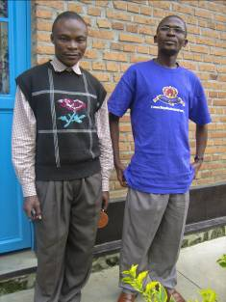
Chaplains and prison workers need times for renewal. Their task is gargantuan, depressing, heartbreaking. They crave training. They feel helpless faced with the material, emotional and spiritual needs of those both rightfully and wrongfully imprisoned. They are asked to support families on the outside, and wonder how to do it. They look at the issues of reparation and restoration and pray for creativity. They work as agents of hope despite often feeling the hopelessness in their own situations. In Gisenyi, Rwanda, at the present time, there is a backlog of over 400 genocide perpetrators waiting for a chaplain to begin a process of facilitation between them and their victims. (This was largely a result of God blessing the work of FEP and Just.Equipping). There is not a Rwandan franc with which to begin the work.

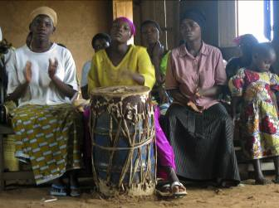
And yet, and yet… this is far from the whole story. We spent many happy hours singing, trying to dance, sharing and praying with our beloved brothers and sisters. We had wonderful worship experiences with prisoners and victims. We enjoyed every morsel of local food prepared for us. The rainbow birds and lizards were enchanting. The children were hauntingly beautiful. The women were towers of strength, and the men models in the face of adversity. The young people are startlingly enthusiastic. The rolling hills and tropical forests were close to Eden. The sun, a reflection of the Son as he gathers all in his arms.

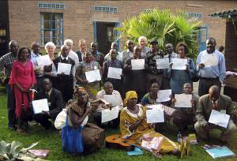
As we look ahead, we remain convinced of the crucial role that serious training will play in the future of chaplaincy and corrections in these and many other countries. We are overwhelmed with requests for teaching from chaplains, administrators, justice workers, volunteers and clergy at large. The community outside prison also wants help to start again, to reduce violence and heal past brutality and present corruption. Churches need encouraging. They need to have their role clarified. Young people want a chance at education and employment. We are prepared to continue to put teaching teams together to answer these requests. We will not be able to do anything without financial support and partnerships. As you may know, participants in our courses and seminars must be fed, accommodated and helped with transportation, as they simply would not have the financial means to attend on their own. Our team members have been wonderfully adept at trying to raise their own support to cover airfare, in country travel and accommodation.
Once a year, we continue to bring a small number of students to Queen’s Theological College, Kingston, Ontario, for the RJ Intensive spring session each May. We are grateful for QTC’s support and partnering with us in so many ways.
We have put together one small manual on RJ, and would like to work on producing materials in French – perhaps even translations of some of the important books available in English.
We bring copies of RJ books, pens and paper to each participant, and supply our own flip chart paper, markers, photocopies and any other necessary teaching supplies.
We are happy to bring wider needs shared with us back to friends and churches in our own context. We call this the ‘Holy Ripple Effect’. So far, several theology and nursing students have been helped with tuition.

Well, where to stop? With a huge word of appreciation to all of you who have made our work possible, who pray for us and who carry in many small and big ways the burdens that we bear.

Thank you.

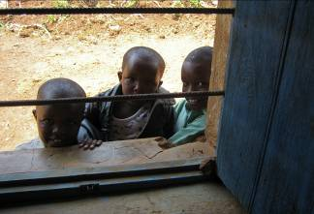
Judy Allard, Executive Director
Just.Equipping
P.O. Box 71053
Ottawa ON K1P 2W0
Canada

Tel: 613-996-3600
allard@justequipping.org
www.justequipping.org

