**Report on Mission 7  
Africa Great Lakes Region   
January – April, 2012  
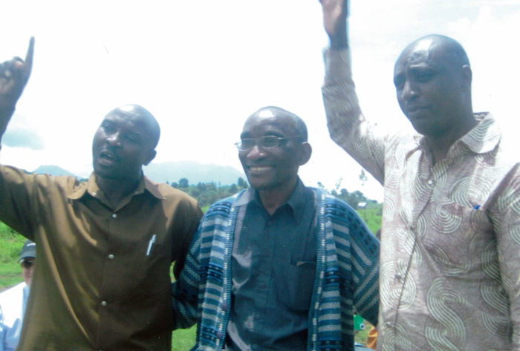**

***‘Exceedingly abundantly above all that we could ask or imagine’ Eph3:20***

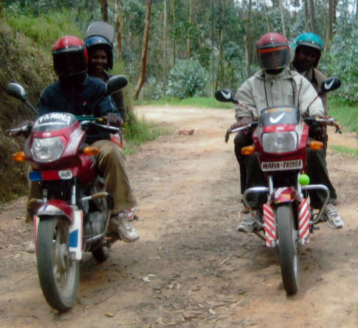We hung on to this verse throughout our time back in Rwanda and RDCongo. Some days we felt that we had all decided to jump off a cliff together. Other times, we felt ensconced in each other’s love. More than once, we felt very alone and incapable. Yet, at the end of the day, we would sit together at the dinner table and marvel at what God had done with our shaky efforts. All praise and thanks belong to God.

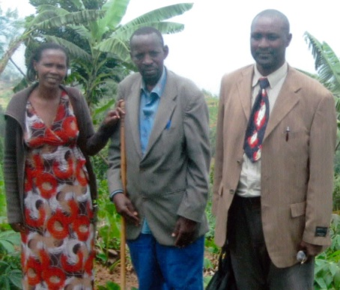So this is what happens in Gisenyi, the town in the north of Rwanda on the RDCongo border where we live. Fine and Canisius (two of the five chaplains trained in the Victim-Genocide Offender Protocol) sit with Lazare and choose 3 or 4 letters destined for a certain area of this mountainous little country. They make sure that the name of the victim is clear in the letter, and that the offender has given a clear explanation of his actions during the attack. They pray and try to get a good night’s sleep. Very early the next morning, they set out to find the victim mentioned in Letter 1. They hope that after 18 years, someone in the district will still remember or even know this person, and that they will be able to give them directions. They take a bus to the spot on the highway where the road up the mountain starts. Then, they get off, find two motos with drivers to rent for the day, and start the kidney-shaking trek on the stony trails up the mountain. This can take several hours. When the motos can go no further, they set out on foot, climbing and slipping their way into the village. Once there, they meet with the local authorities and explain what they are doing. They have a letter from a prisoner (duly stamped by prison authorities) to deliver to the survivors of someone they harmed – usually killed - during the genocide. Would anyone know this family? Where do they live? Are there any survivors?

The discussions begin. After some conversation and perhaps the offering of a drink of Fanta, someone says that this sounds like a good idea and that Onesime might be found in his field on the other side of this hill. Fine and Canisius set out to find him, and then find a tree nearby to stand under while they introduce themselves. Hopefully Canisius, who is from this area, will know someone related to Onesime and the family connections which are so important for trust will be established. Finally, it is time to tell Onesime that they are carrying a letter for him from the person who, during the 100 days of massacres in 1994, wiped out his family. Does he want to read it? Can he read? Very often, the victim asks Fine to read the letter out loud which she does with great trepidation. Onesime then takes the letter and looks over it himself before throwing it down. He sits down on the ground and pulls his coat over his head. Silence. Then slowly the sobbing and shaking starts….Sometimes half an hour can go by before one of the chaplains is able to ask if he would like to talk about it. Onesime slowly reveals that for 18 years he thought someone from the neighbouring hill had killed his family. Now he has discovered that it was a young man that his family had taken in as one of their own. Even though he was not a Tutsi, they never thought he would betray them as they had loved him as a son. Onesime has also just discovered that his youngest son, three years old, had run in fear to a neighbor. She sheltered him until the offender came and demanded that he be turned over to the gang. He then picked him up by the legs and swung him against a tree until he died.

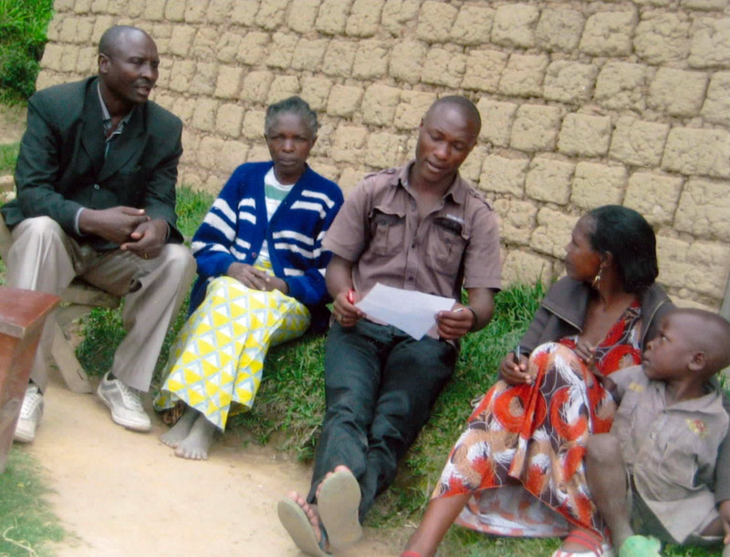Fine hugs Onesime while he finishes sobbing. Canisius asks if he would like prayer. Words fail Canisius as he prays with him. Then they walk back to the hamlet and buy Fantas and try to make sense of these revelations. Onesime relives all his memories of the event with them. He is broken, then furious and finally resolved to find some sort of peace. When the chaplains ask if he would like to come to the prison outside the city and meet face to face with the offender, he is at first speechless. Then he slowly says yes. He has more questions to ask – details of the killings. He wants to know where the bodies of his wife and children are. He wants to hear regret in the offender’s voice and see it in his eyes. He wants to try to forgive. Mobile phone numbers are exchanged, tentative plans made, and Onesime finds it hard to say goodbye to the chaplains. He accompanies them back down the mountain for a couple of kilometers. Fine slips him 1000FRW to buy food for the evening meal.

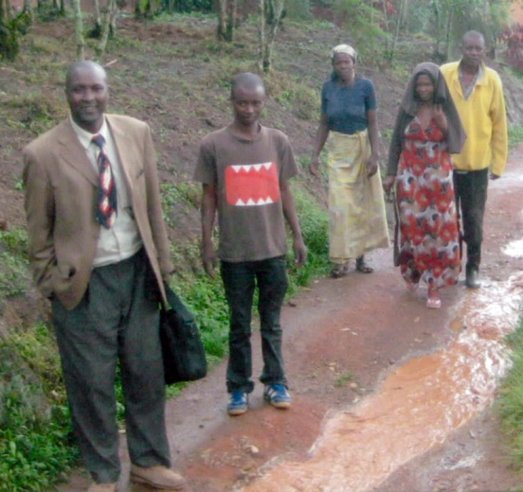When Fine and Canisius reach the spot on the trail where the two moto drivers are waiting for them, they are surprised to see them already helmeted up and ready to leave. It is getting dark and they had decided to leave without them. Thank God they arrive just in time to start for home the same night. But, of course, there had only been time to deliver one letter, and so the same journey will have to be made again….As they start down the mountain it begins to rain and the terrain becomes treacherous. Fine decides she would almost rather sleep in the rough than risk her life on the steep and muddy trails. Finally they make it to the bus stop where someone gives them shelter in their doorway while they wait. An hour later, they arrive back at our house, cold, wet and exhausted. We have a hot meal and dry clothes waiting. Then we sit together in the living room and listen to every detail of the day. Fine cries unconsolably as she recounts the grief and cruelty. She wonders again for the 100th time if this is the way her own father was killed, and where his body is. Canisius just shakes his head and covers his face in his hands. We pray together, get them a lift to their homes and make plans to meet the next day.

Onesime’s journey of healing has begun. It is far from over. There are many challenges ahead, many trips, expenditures, disappointments and stress. We, however, know that he is already a stronger man than he was that morning. We have seen over and over the power of forgiveness and healing, the new capacity to move on, the possibility of peace in the farthest corners of this land beloved by God. Now the chaplains must return soon to the prison and report back to the offender. He will be overjoyed if the victim agreed to receive his letter, devastated if he did not.

And the next day, the chaplains set out again. We will stretch the funds you send and continue this mission sent to us from God until all the letters we received from offenders of the Gisenyi Prison have been delivered and the process of reconciliation taken as far as possible. Many amazing and sacred encounters have taken place in prison and at the Petit Sanctuaire Gisenyi. Faith tells us there are many more to come!

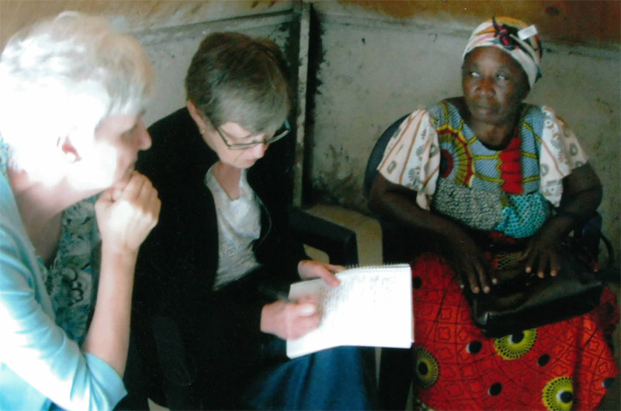Just.Equipping and the ICOPUR (Initiative communautaire pour l’unité et la réconciliation) chaplains have delivered over 200 of the original 400 letters. We already have been asked to deliver 300 more letters from the same prison and many more from other prisons in the country. This is something to which we cannot commit until we have the resources necessary and feel that the Lord is directing in that way. Pray with us.

Much of our time was also spent with the chaplaincy workers from Goma, RDCongo under the banner of PJRIDI (Promotion de la justice réparatrice et des initiatives de développement integral) and the leadership of Simeon Muhunga. They are just amazing! We were able to assure them a very small monthly stipend for one year. They immediately developed a work plan to cover the Goma Prison, the work of the Petit Sanctuaire Goma (the community chaplaincy arm of their ministry) and their community mediation. Thanks to your gifts, they delivered baby packages to the women and children in custody, food to the juveniles in prison – many of whom could hardly walk from hunger, disinfectant for the latrines, kerosene for lamps in the prison (there is no electricity) and emergency health care for several inmates.

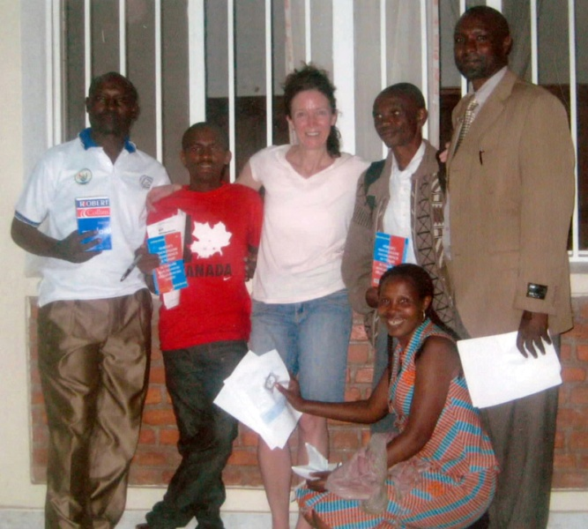They delivered sheets to those sleeping in the rough, pens, chalk, paper and blackboard to start a school program for the juveniles, clothing and much coveted underwear for the women, T-shirts, soccer balls and some games for the men. We had brought some Bibles and dictionaries which were snapped up, and we hope to bring more Bibles next time. We were able to begin to stock the small dispensary at the Petit Sanctuaire. Bethany Church gave each chaplain a new pair of shoes for their long daily treks on the lava rock of Goma. About five children went back to school through designated gifts for education.

All this happens in a climate of political upheaval, danger and violence, extreme poverty and corruption. Again, what they accomplish is ‘exceedingly abundantly above all that we could ask or imagine’. Pray for protection, harmony and perseverance for these saints. Pray also for the prisoners here who live in horrible conditions. Pray especially that the local civil and church communities will step up and provide food for these starving souls. Pray for clean, accessible water for everyone.

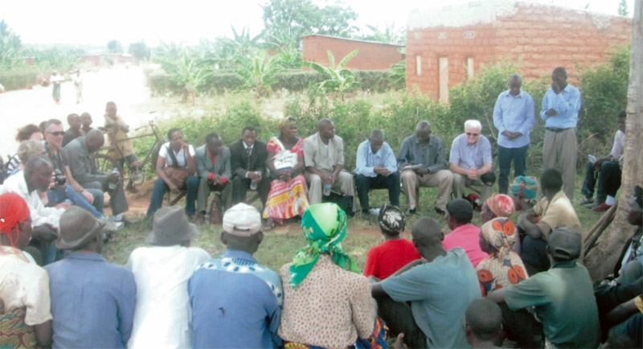We rejoiced in our visits to and involvement with the reconciliation villages in Bugesera (with Pascal Niyomugabo) and Ruhengeri (with Deo Gashagaza). Fifty percent of the inhabitants are genocide survivors or victims, and fifty percent are perpetrators or offenders. We saw once again how hard it is for these people to live with each other every day and wished we could stretch our budget to help more with tin for roofing, outhouses, water pipes, school costs and so much more.

Every day, we provided hospitality and many, many meals to all who dropped by our house, the ‘Grand Sanctuaire’. Groups who would not normally sit together laughed around the same table. We often held our grains of mustard seed and prayed together for faith to move mountains. We used our homemade flipchart to explore together issues both spiritual and practical. We met with local and national authorities and did endless paperwork. We regret that we were not able to spend time with Jean Bosco and Barnabas Africa in Burundi, but hope to fit this in next time.

My mind is full of faces, details and stories which I cannot include here but which speak of God’s love and concern to these brothers and sisters of the Great Lakes Region. All this is because of you and your willingness to support the Just.Equipping Team with money, donations of all sorts (those nail clippers are great!) and prayers. I wish every one of you could see what joy you have brought to so many!

Judy and Pierre Allard

with

Eileen Henderson

and Lillian Amell , Luc Desforges, Deborah Martin Koop.

